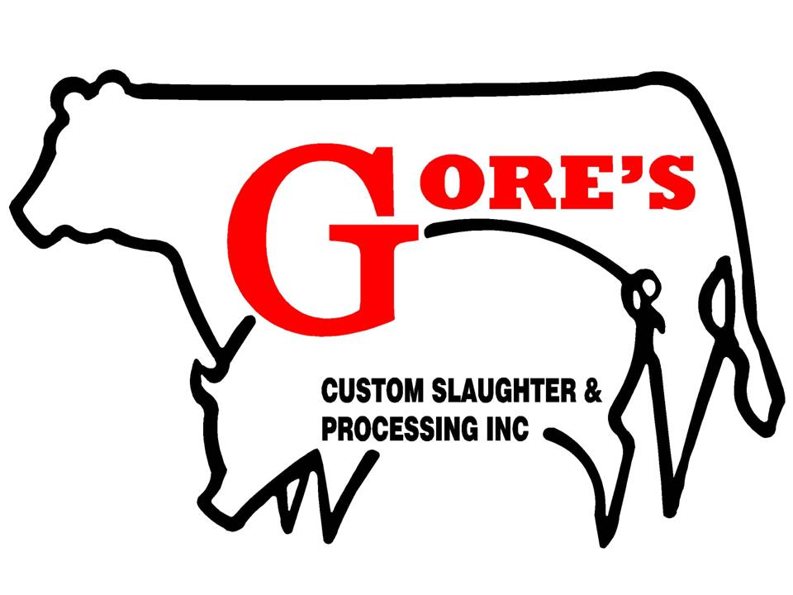
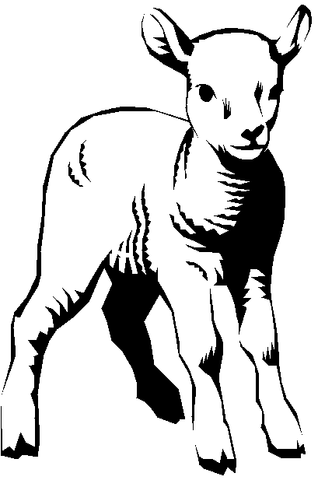
Directions for Cutting My Lamb:

Loin
( ) Chops ____” thick ____ per package
( ) Roast

Ribs
( ) Chops ____” thick ____ per package
( ) Whole Rack of Ribs

Shoulder
( ) Boneless Roast
( ) Bone-In Roast
( ) Kabobs
( ) Chops ____” thick ____ per package

Leg
( ) Boneless Roast
( ) Bone-In Roast
( ) Kabobs
( ) Chops ____” thick ____ per package

Burger ( )
Stew Meat ( )

Leg Shanks ( )

NAME: _______________________________________________
PHONE: ______________________________________________
ADDRESS: _____________________________________________
BOUGHT FROM: _______________________________________

